Acknowledgement

I, Biswanandan Hota, owe my gratitude to all the people who helped and supported me to finish the internship. I thank my mentors Mr. Subhankar Ray, Axle Div. Head, Business Development, and Mr. Rahul Kumar, Sr Engineer Marketing, RSB Transmissions (I) Ltd. For their monitoring, and constant encouragement throughout the course of this internship. Their help and guidance from time to time shall help me a long way in the journey of life and career on which I am about to embark. I would also like to thank Mrs. Jaya Singh, Lead HR Head, Auto division, Jamshedpur for trusting me and providing me with opportunities to represent the organization in both Regional and National levels.

I would also thank RSB Transmissions (I) Ltd. for supporting me and giving me the opportunity to work on this internship and helping me improve my skills and knowledge, giving me exposure to a proper work environment.

Declaration By The Student

I, Biswanandan Hota, solemnly declare that the project report is based on my own work carried out during the course of my internship under the supervision of Mr. Shubhankar Ray and Mr. Rahul Kumar.

I assert the statements made and conclusions drawn are an outcome of my

internship. I further certify that:

1. The work contained in the report is original and has been done by me under the general supervision of my supervisor.

2. Whenever I have used materials (data, theoretical analysis, and text) from other sources, I have given due credit to them in the text of the report and giving their details in the references.

Biswanandan Hota

**Table of Content**

**Executive Summary**…………………………………………………………………………………..4

**Company Profile……………….**…………………………………………………………………….4-5

**Market Segments**………………………………………………………………………………………6

**Products**………………………………………………………………………………………………….7-8

**International Partnerships**…………………………………………………………………………8

**Key Clients of the organization: OEMs**……………………………………………………….9

**CSR Initiatives**……………………………………………………………………………………………10

**Objective**………………………………………………………………………………………………..…11

**Methodology**……………………………………………………………………………………….…...11

**Business Aspect of the problem Identified**……………………………………………....11

**Approach**………………………………………………………………………………………………..…11

**Understanding the Commercial Vehicle Industry**…………………………………12-13

**Commercial Vehicle Industry**…………………………………………………………….………13

**Government Initiative under CV Industry**…………………………………………..…….14

**Analysis**…………………………………………………………………………………………………15-19

**Leading OEM’s Market Share**………………………………………………………………..20-22

**RSB’s Production Contribution to OEM’s (Value)**………………………………….23-24

**Forecast for the Next 5 Years**…………………………………………………………..……24-27

**Sales Prediction of M&HCV Segment Of Top OEMs**………………………………27-29

**Outcome (Contribution to OEMs)**………………………………………………………….29-30

**Suggestions**…………………………………………………………………………………………...30-31

**Bibliography**…………………………………………………………………………………………...32

**Executive Summary**

This study follows a quantitative research approach, involving systematic data collection and rigorous analysis, utilizing both primary and secondary data sources. Its objective is to assess RSB's market share within the Indian automobile industry. The collected data is analyzed to identify patterns and trends relevant to RSB’s Share of Business (SOB) in comparison to OEMs in M&HCV segment.

The Indian automotive sector contributes 7% to the country’s GDP, with domestic automobile sales witnessing a 12.5% year-on-year growth in FY24. This report provides a comprehensive analysis of the Indian commercial vehicle industry and evaluates RSB's overall future prospects as an organization.

**Company Profile**

**RSB Transmissions India Ltd**

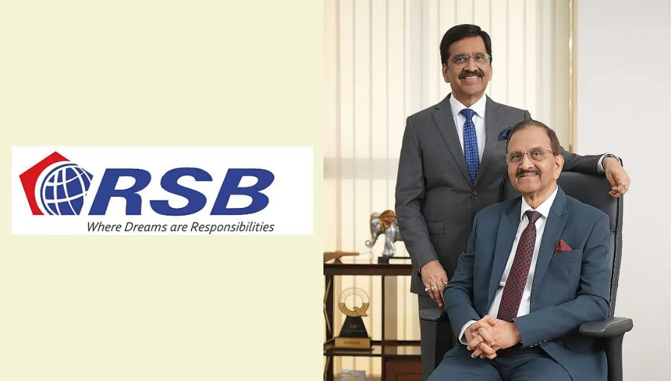

Founded in 1973 by Mr. R.K. Behera, Chairman, and Mr. S.K. Behera, Vice-Chairman, RSB Group specializes in designing and manufacturing components for the automotive, construction, and manufacturing industries. The company currently has an annual sales turnover of INR 3,000 crores.

RSB has received several prestigious awards, including the TPM Excellence Award (Category A) in 2019 and the Deming Award for three of its plants in 2013. The company produces a wide range of auto engineering products, such as propeller shafts, gears, gearboxes, axle beams, fully assembled dummy axles, 5th wheel couplings, machined engine components, and construction equipment aggregates. With expertise in product design, development, testing, and manufacturing of advanced technology products, RSB collaborates with leading Original Equipment Manufacturers (OEMs) in the automobile, construction, and farm equipment sectors. The company has a global presence, with manufacturing facilities in the USA and Mexico, along with a strong domestic footprint in India, operating 11 state-of-the-art manufacturing plants across key automotive hubs. RSB also boasts robust in-house design capabilities through Design Engineering Solutions and vertically integrated manufacturing with an in-house forging facility.

**Vision** “To be amongst the most admired organization with significant global presence.”

**Core Values**

* “Integrity & ethical practices, Customer orientation”
* “Cooperation, Innovation”
* “Agility, Commitment to society & environment”

**Mission**

|  |  |
| --- | --- |
| **Auto Vertical**  **“**Be a socially responsible leading manufacturer of Automotive components & systems to fulfil the prosperity of all stake holders.” | **CMI Vertical**  “To be a leading manufacturer of Aggregates & Attachments for Construction & Minning Industry in India & satisfy all stake holders.” |

**Market Segments**

**Products**



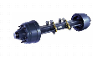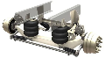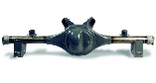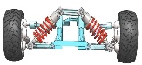

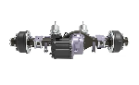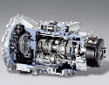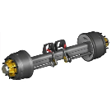

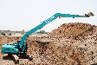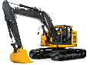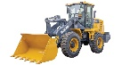

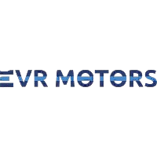**International Partnerships**

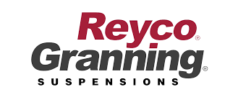

|  |
| --- |
| **Reyco Granning**  **Suspensions** |

|  |
| --- |
| **EVR Motors**  Gears |

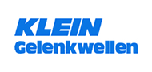



|  |
| --- |
| **Klein**  Propeller Shaft |

|  |
| --- |
| **Shing Shing Long**  CV Driver Shaft |

**Key Clients of the organization: OEM’S (Vertical II- Axle Division)**

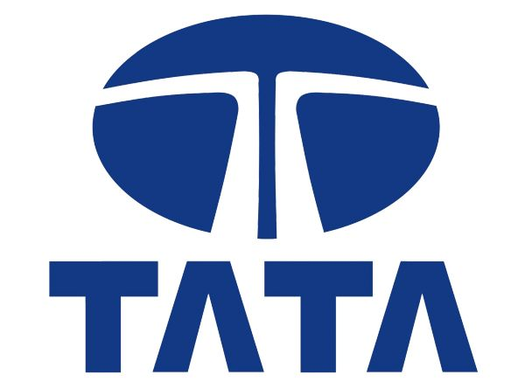



|  |
| --- |
| **Volvo Eicher Commercial Vehicles Limited** |

|  |
| --- |
| **TATA Motors** |

|  |
| --- |
| **Ashok Leyland** |

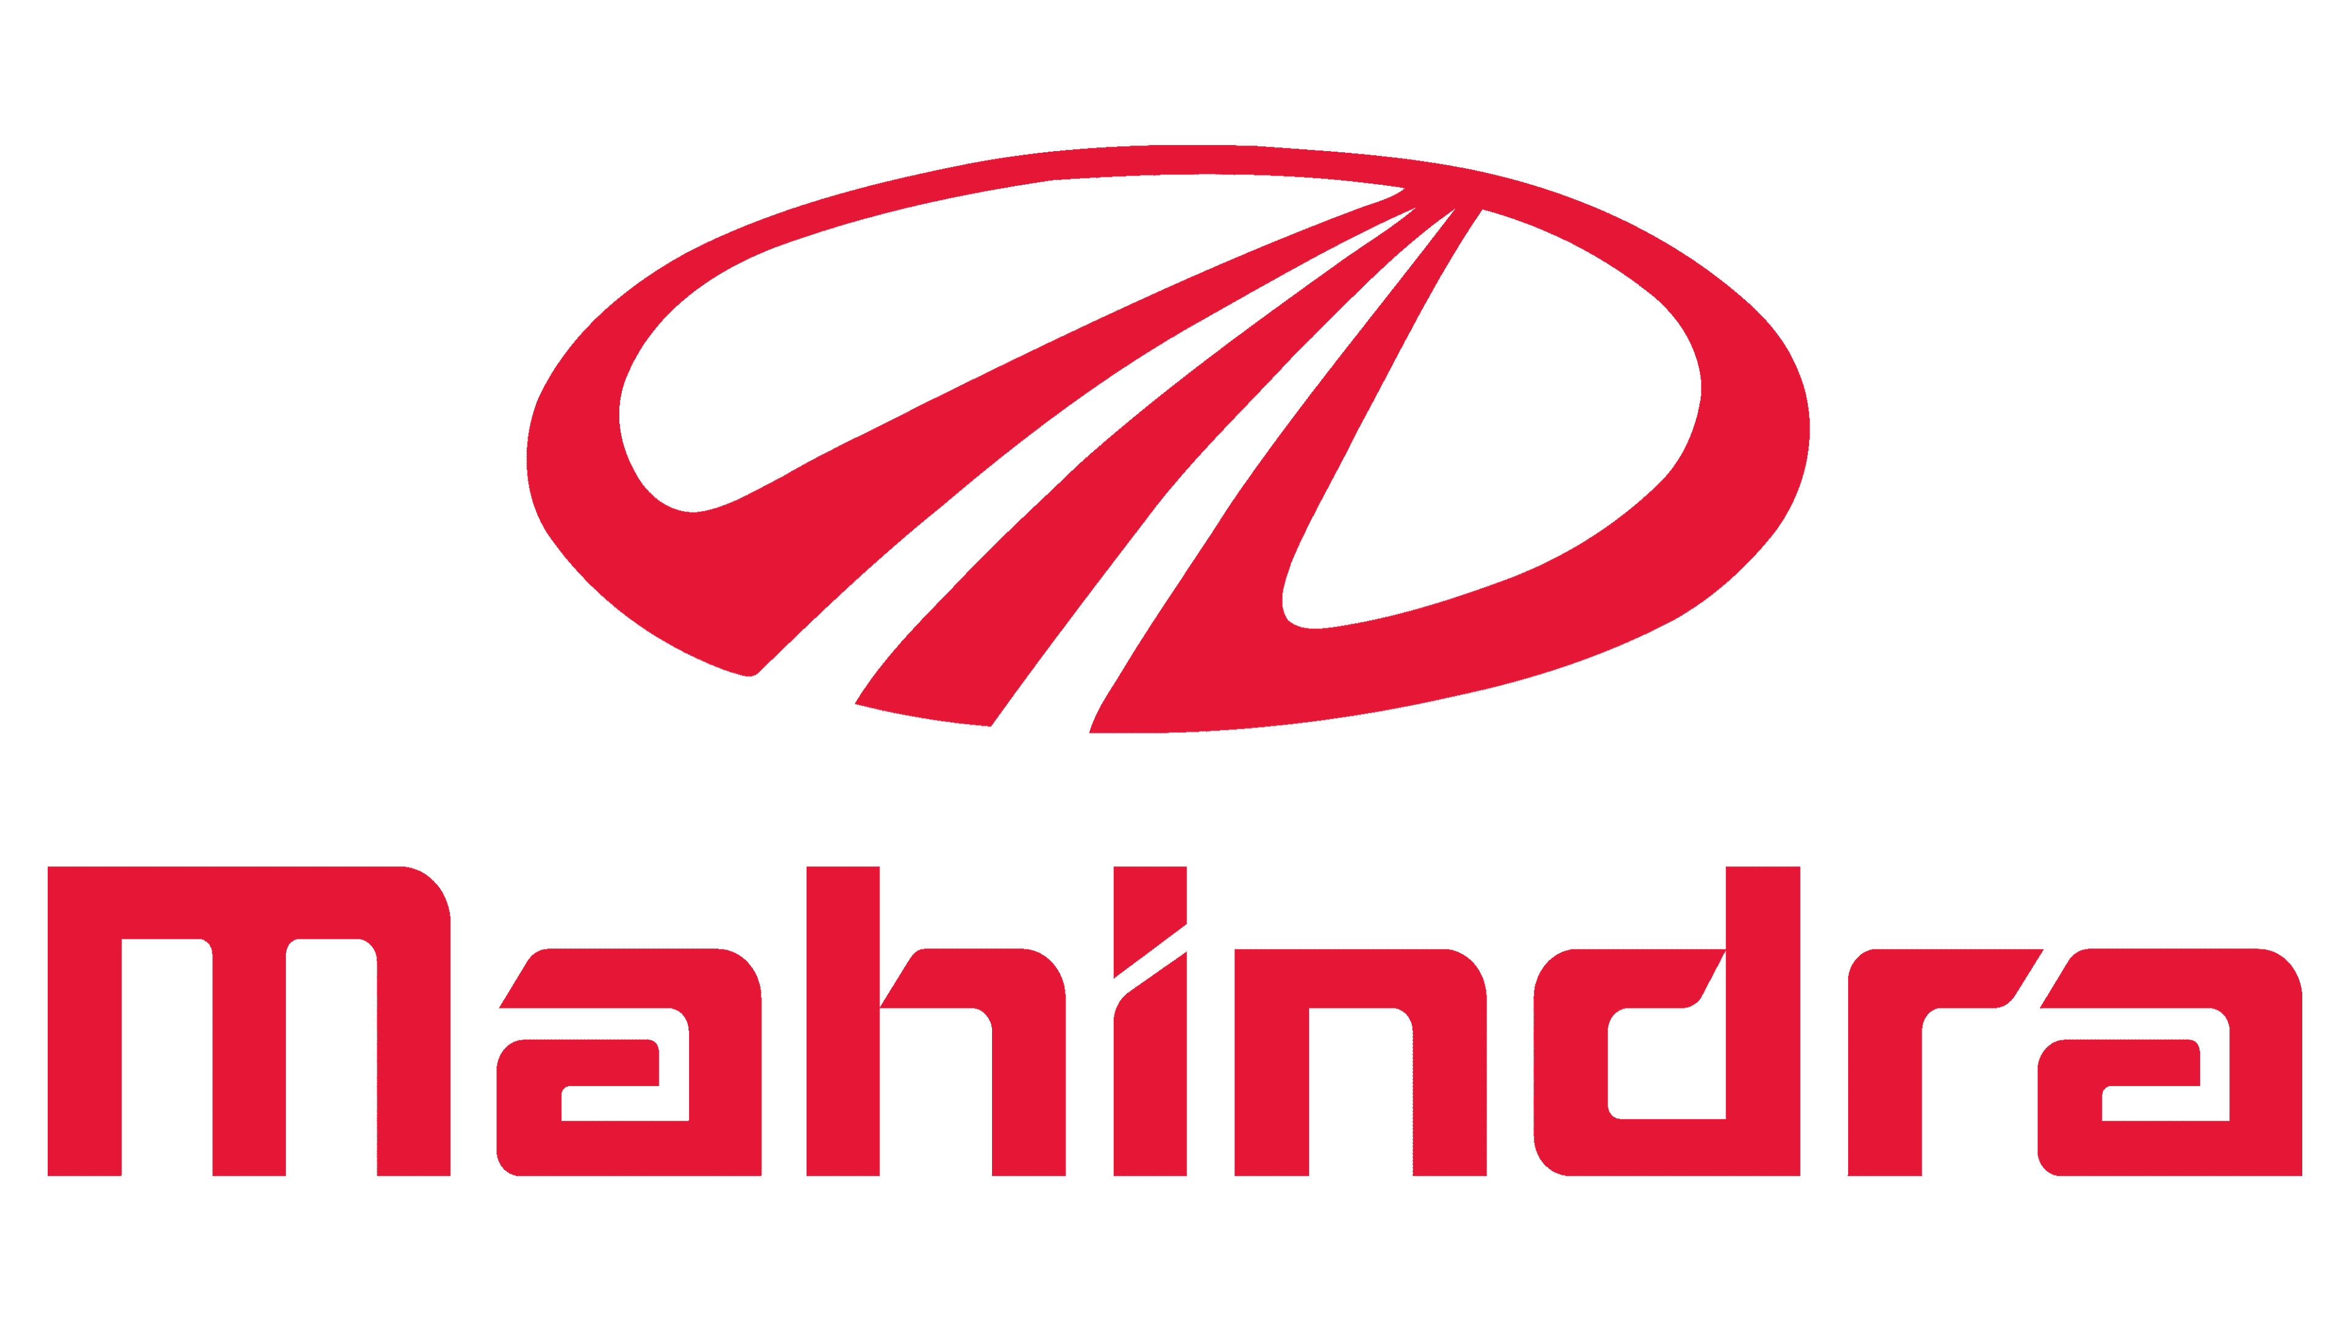

|  |
| --- |
| **Mahindra and Mahindra** |

|  |
| --- |
| **Tata Hendrickson** |

**CSR Initiatives**

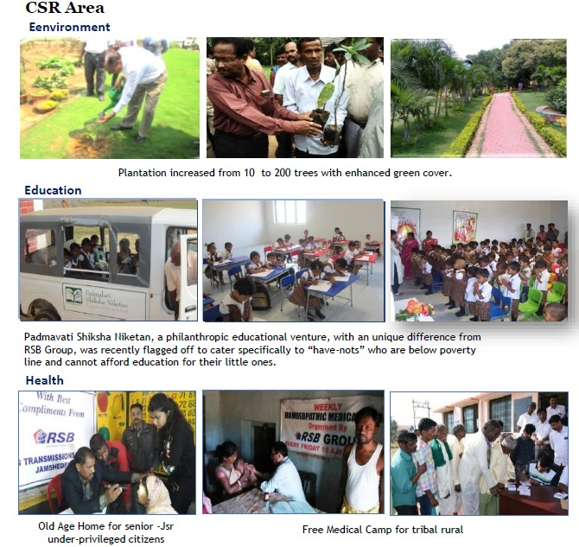**Objective**

To find Share of Business (SOB) of RSB in Indian Automobile Market with respect to OEM’S in M&HCV Segment.

**Methodology**

This study focuses on a primary quantitative research approach, which allows for systematic data collection, rigorous analysis, derived from both primary and secondary data. By employing this approach, the research aims to provide the market share of RSB within the Indian Automobile Market.

**Business aspect of the Problem Identified**

* Market analysis of OEM’s and forecast for the next 5 years would help the organization understand the evolving market trends.
* Understanding RSB’s contribution in commercial vehicle (cv) segment.
* Prediction of sales for the next 5 years in M&HCV segment of top OEMs.

**Approach**

This research is primarily quantitative and aims to assess RSB's Share of Business (SOB) in relation to OEMs in M&HCV Segment. The study is based on secondary data sourced from industry reports, reliable databases such as SIAM, and board reports, which provide insights into market trends, industry dynamics, and the competitive landscape of the Indian automobile sector. Additionally, primary data collected from the organization further supports the analysis. The gathered data is systematically examined to identify patterns, trends, and key insights relevant to RSB's SOB in the context of OEMs in M&HCV Segment.

**Understanding the Commercial Vehicle industry**

**Indian Automobile Industry**

The Indian automotive industry contributes 7% to the nation's GDP. In FY24, automobile sales are expected to grow between 7% and 9%, with the commercial vehicle (CV) segment projected to increase by 5% to 7%, benefiting from a structural upcycle observed in recent years.

In FY23, domestic automobile sales saw a 20% year-on-year growth, driven by factors such as the implementation of BS-VI Phase-II emission norms, improved semiconductor chip availability, and pent-up demand. However, exports declined by 15% year-on-year during the same period.

The graph illustrates an overall upward trend in domestic automobile sales growth, with notable declines in 2008 due to the global economic crisis and in 2020 due to the pandemic. Despite these setbacks, the industry has been recovering, showing signs of stabilization by 2023.

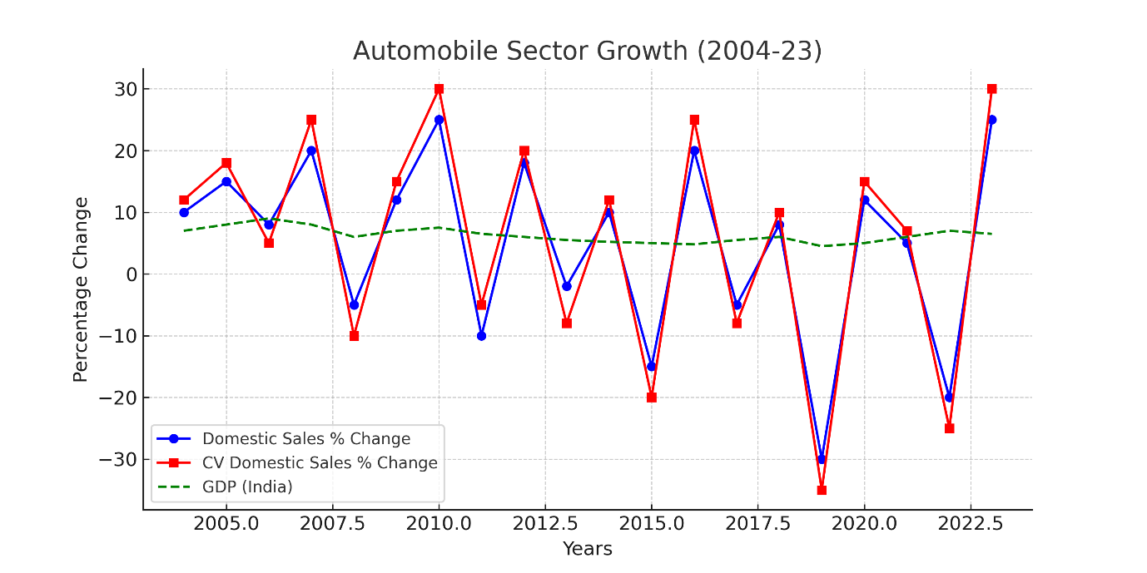Additionally, the commercial vehicle (CV) sector has experienced steady growth over time. Historical data indicates that CV demand is strongly linked to the country’s GDP growth rate.

Hence, a rise or decline in CV demand is often seen as a reflection of an economic upturn or downturn, respectively. The Indian CV industry serves as a crucial backbone of the nation's economy.

**Commercial Vehicle Industry**

**Trends in CV Industry**

The commercial vehicle (CV) segment recorded a 34% year-on-year sales growth in FY23, driven by strong demand sentiment across the sector, largely fueled by the central government's infrastructure push. However, exports declined, impacted by ongoing geopolitical challenges.

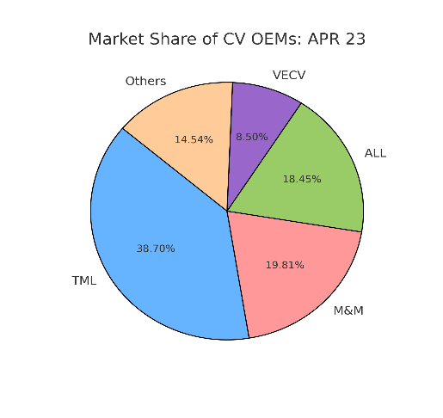**CV Industry Segment-Wise Overview**

The Indian CV segment is divided into

vehicles with Gross Vehicle Weight (GVW).

Below 7.5T GVW are LCVs, whereas above

7.5T are MCHCVs.

M&HCV- Caters to the logistic businesses for long-distance transfer of goods and companies in the infrastructure, metal, and mining sectors.

The Light Commercial Vehicle (LCV) segment plays a crucial role in short-haul transportation and last-mile connectivity, with its growth reflecting an increase in consumption demand. This segment is further divided into goods and passenger carriers.

Since the CV industry is closely tied to the nation’s economic performance, it is cyclical in nature and highly responsive to technological advancements. With the implementation of stringent environmental regulations and the growing demand for advanced technology vehicles, manufacturers must either establish strong in-house R&D centres or collaborate with technology partners. This has led to higher entry barriers, shaping the industry into an oligopolistic market.

**Government Initiative under CV Industry**

The Indian government has implemented several initiatives to bolster the Commercial Vehicle (CV) industry, focusing on sustainability, technological advancement, and infrastructure development:

**1. FAME India Scheme (Faster Adoption and Manufacturing of Electric and Hybrid Vehicles):** Launched to promote the adoption of electric vehicles (EVs), this scheme offers incentives for the purchase of EVs, including commercial vehicles. It aims to reduce vehicular emissions and dependence on fossil fuels.

**2. Production Linked Incentive (PLI) Scheme:** This scheme provides incentives to manufacturers for increasing domestic production of automotive components and vehicles, with a focus on electric and hydrogen fuel cell vehicles. It aims to enhance the global competitiveness of the Indian automotive sector.

**3. National Automotive Testing and R&D Infrastructure Project (NATRiP):** NATRiP focuses on establishing state-of-the-art testing, validation, and R&D infrastructure to support the automotive industry, including the CV sector. It aims to create core global competencies and facilitate seamless integration with the world.

**4. Vehicle Scrappage Policy:** Introduced to phase out old, polluting vehicles, this policy mandates fitness tests for commercial vehicles older than 15 years. Unfit vehicles are to be scrapped, promoting the purchase of newer, more efficient CVs and reducing environmental impact.

**5. Development of Multi-Modal Logistics Parks (MMLPs):** The government is developing MMLPs to improve the efficiency of freight transportation. These parks aim to lower logistics costs, reduce vehicular pollution, and enhance the tracking and traceability of consignments through infrastructural and technological interventions.

**6. Promotion of Liquefied Natural Gas (LNG) in Heavy-Duty Vehicles:** To reduce pollution and reliance on diesel, the government plans to transition a significant portion of heavy-duty long-haul trucks to LNG. This initiative aligns with India's commitment to sustainable transportation solutions.

These initiatives collectively aim to modernize the CV industry, promote environmental sustainability, and enhance the sector's contribution to India's economic growth.

**Analysis**

The Indian automotive market is experiencing significant growth, driven by an expanding middle class, technological advancements, and government initiatives. This surge is expected to increase demand across electric vehicles (EVs), passenger vehicles (PVs), commercial vehicles (CVs), and two-wheelers.

Government policies, such as tax incentives, vehicle scrappage schemes, and rising disposable incomes, are making the market more accessible to a wider population. Additionally, infrastructure investments are set to enhance CV production to meet this rising demand.

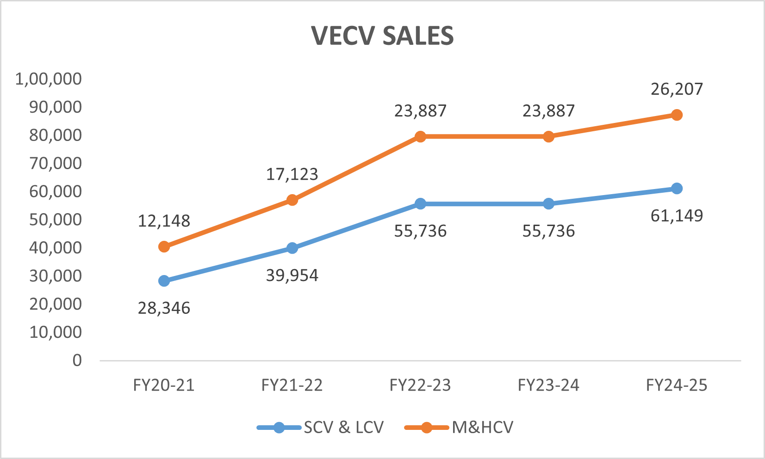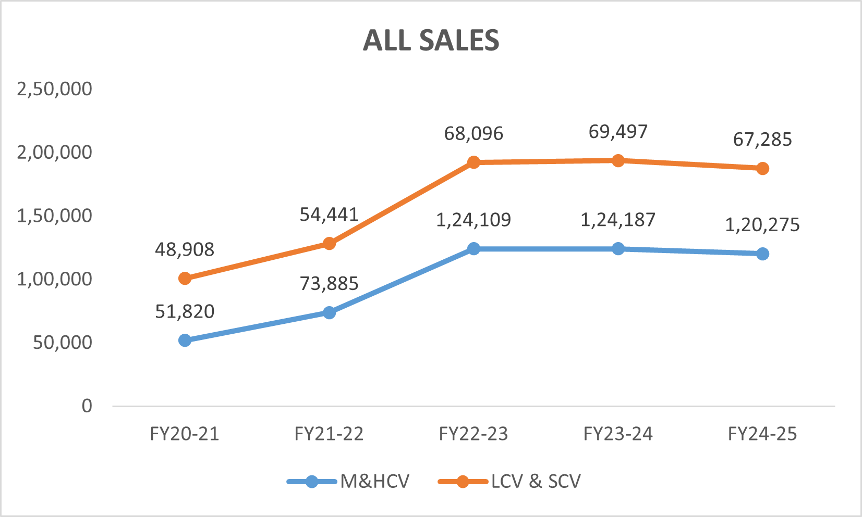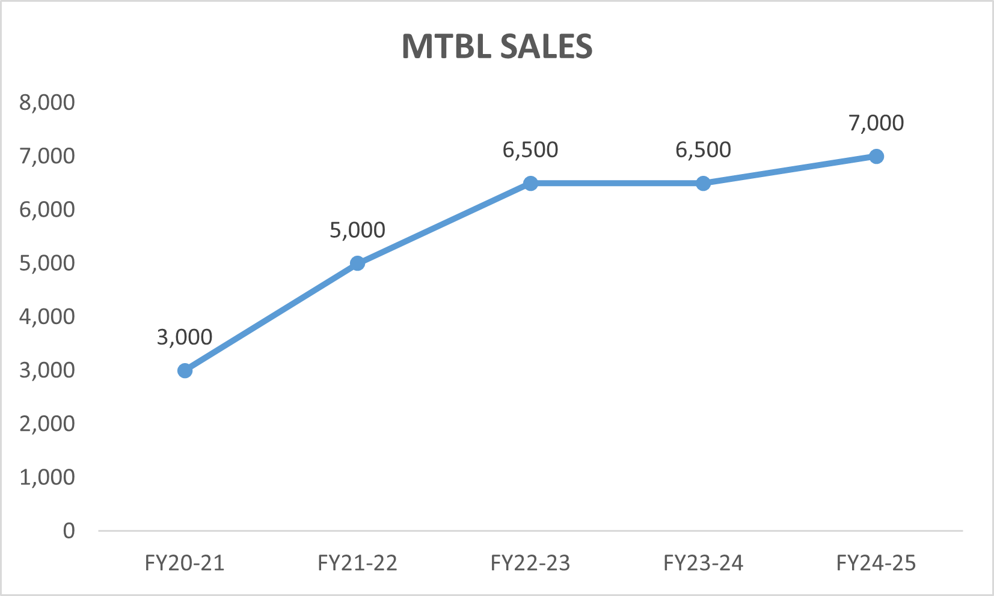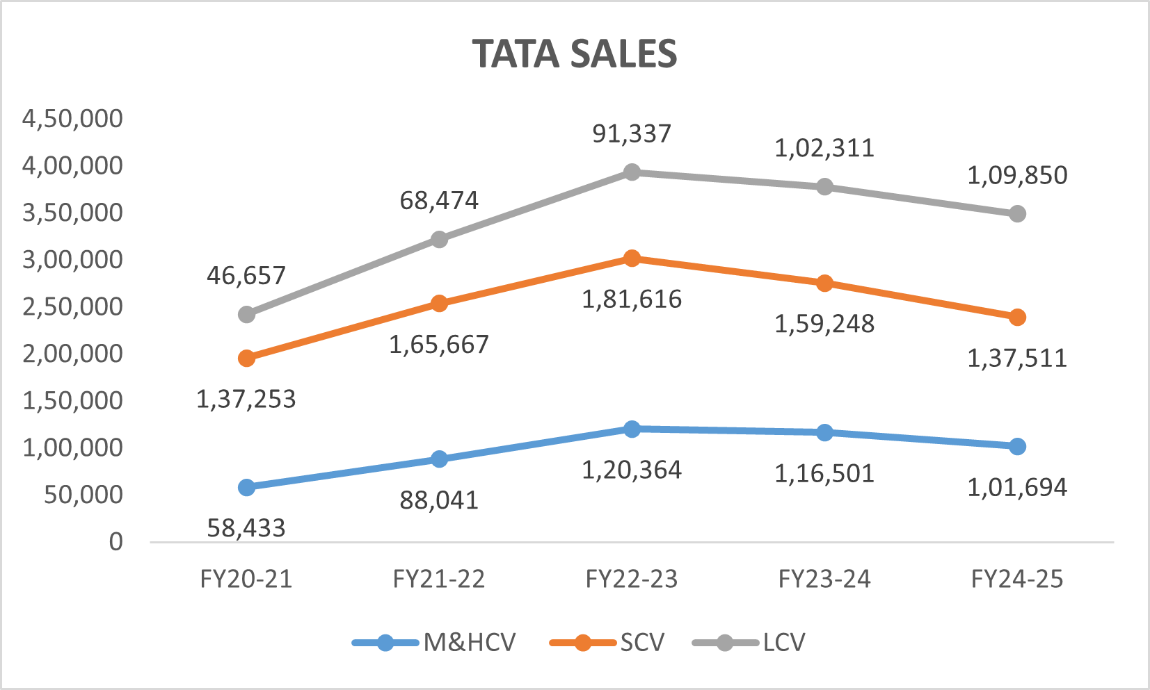Given the strong correlation between CV sales and India's GDP, a continued upward trend in sales revenue could indicate steady GDP growth, with projections suggesting it may peak around 2031, approximately seven years from now. 5 years of past data of the overall unit sales of the country’s leading OEM’s were collected and forecasted as such:

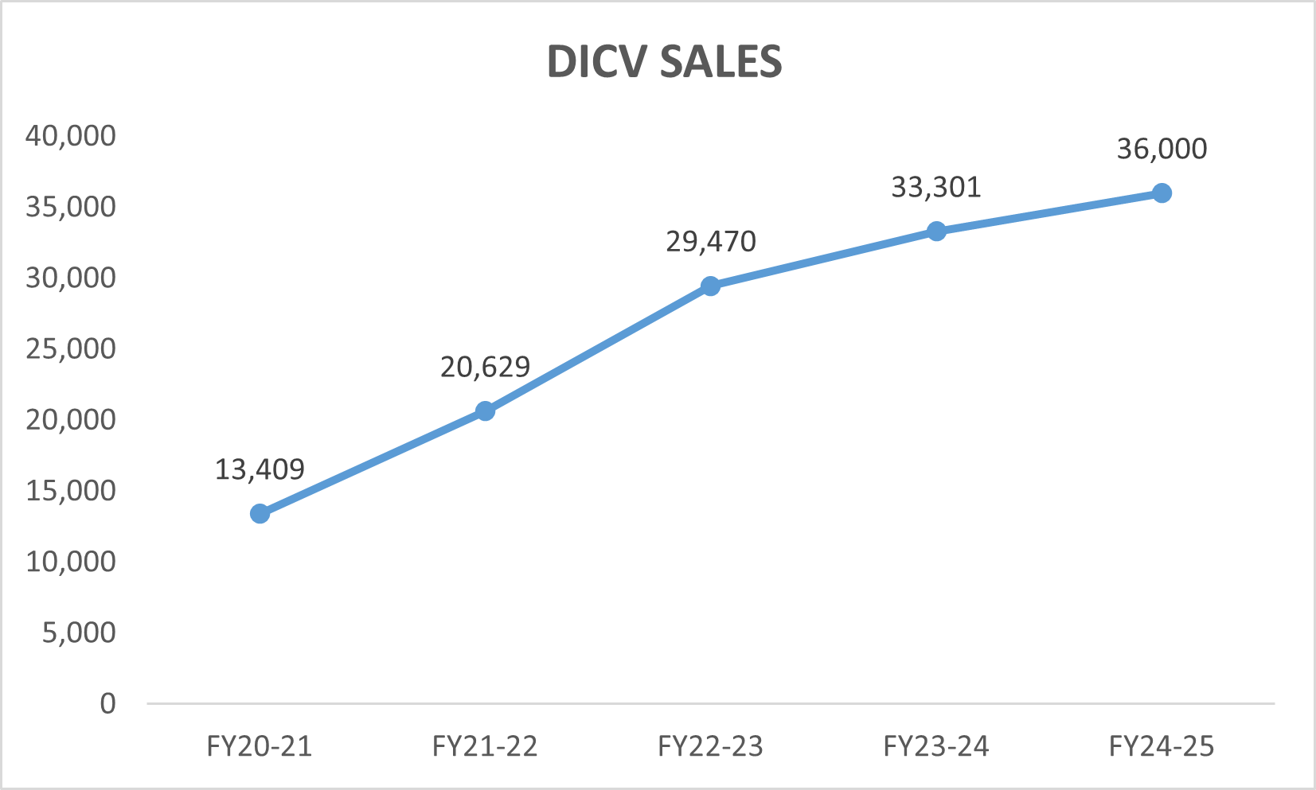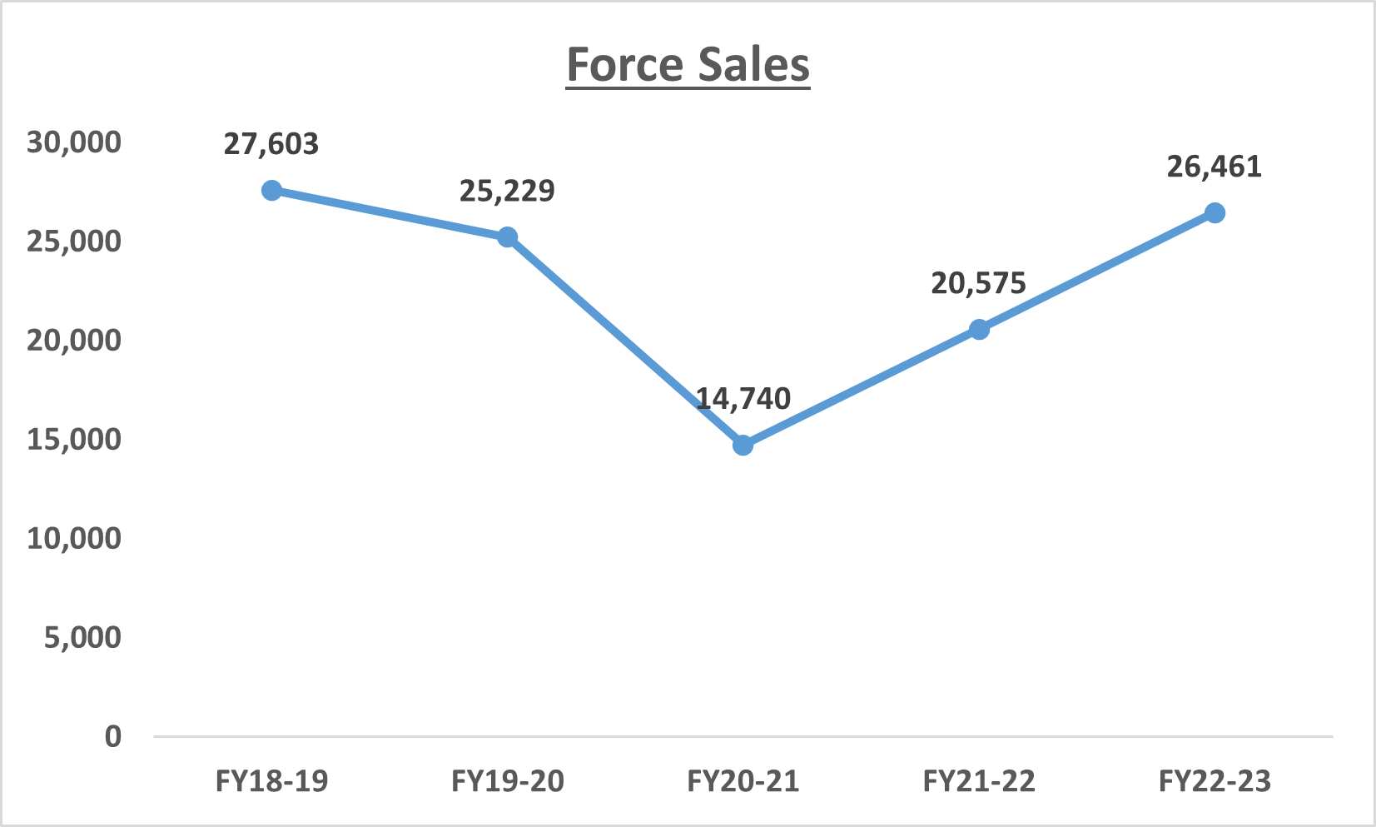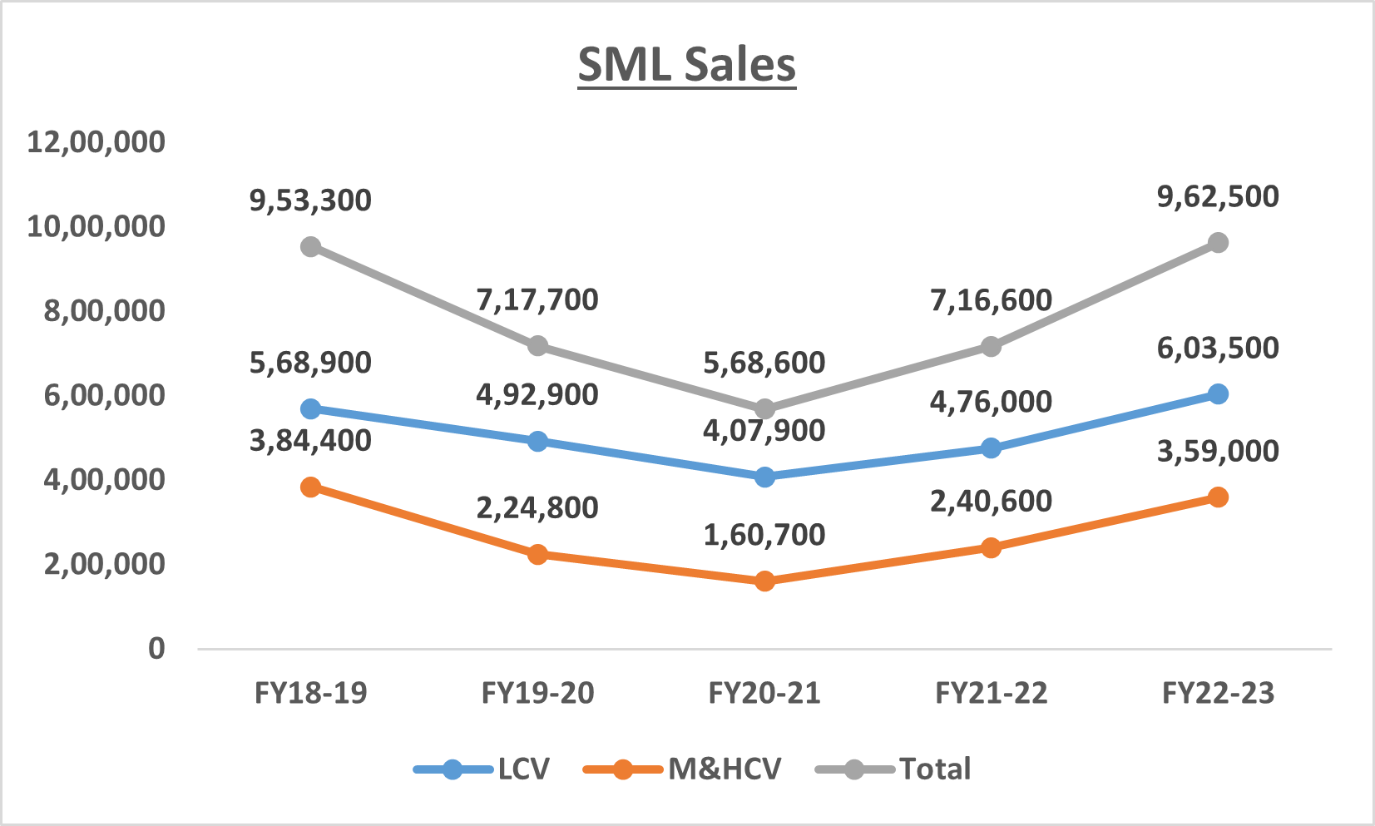

**TATA**: The TATA Sales chart illustrates the sales trends of different commercial vehicle (CV) segments—M&HCV Trucks, SCV, and LCV—across five financial years (FY20-21to FY24-25). Tata's commercial vehicle sales (FY20-21to FY24-25) show significant fluctuations across segments:

1. M&HCV (Medium & Heavy Commercial Vehicles):

* Peaked in FY22-23 at [109,850] units
* Saw a significant drop in FY23-24 ([68,474]) before partial recovery in FY24-25 ([88,041])

1. SCV (Small Commercial Vehicles):

* Dramatic growth from [46,657] in FY20-21 to [181,616] in FY21-22
* Gradual decline post-peak, stabilizing around [137,000] units in recent years

1. LCV (Light Commercial Vehicles):

* Steady decline from [165,667] in FY20-21 to [58,433] in FY24-25
* Most affected segment with -65% reduction over 5 years

**Ashok Leyland**: The graph shows sales data for two vehicle categories - M&HCV (Medium & Heavy Commercial Vehicles) and LCV & SCV (Light Commercial Vehicles & Small Commercial Vehicles) over five fiscal years from FY20-21 to FY24-25.

* LCV & SCV segment consistently shows higher sales numbers compared to M&HCV throughout the period:

- Started at 48,908 units in FY20-21

- Peaked at 69,497 units in FY23-24

- Shows a slight decline to 67,285 units in FY24-25

* M&HCV segment shows significant growth in the early years:

- Started at 51,820 units in FY20-21

- Saw substantial growth to 124,109 units in FY22-23

- Remained relatively stable around 124,000 units in FY23-24

- Shows a slight decrease to 120,275 units in FY24-25

The overall trend suggests a maturing market for both vehicle categories, with the initial rapid growth phase potentially coming to an end.

**Mahindra:** The graph shows MTBL sales data over five fiscal years from FY20-21 to FY24-25, displaying a generally upward trend.

1. **Sales progression over the years:**

* Started at 3,000 units in FY20-21
* Increased significantly to 5,000 units in FY21-22 (67% growth)
* Jumped to 6,500 units in FY22-23 (30% growth)
* Remained stable at 6,500 units in FY23-24 (no growth)
* Projected to reach 7,000 units in FY24-25 (7.7% growth)

1. **The growth pattern shows three distinct phases:**

* Rapid growth phase (FY20-21 to FY22-23)
* Plateau phase (FY22-23 to FY23-24)
* Moderate growth resumption (FY23-24 to FY24-25)

**VECV:** The graph tracks VECV (VE Commercial Vehicles) sales data across two segments - SCV & LCV (Small & Light Commercial Vehicles) and M&HCV (Medium & Heavy Commercial Vehicles) from FY20-21 to FY24-25.

1. **M&HCV segment performance:**

* Started at 12,148 units in FY20-21
* Grew steadily to 17,123 units in FY21-22 (41% growth)
* Significant jump to 23,887 units in FY22-23 (39% growth)
* Remained flat at 23,887 units in FY23-24
* Projected to reach 26,207 units in FY24-25 (9.7% growth)

1. **SCV & LCV segment performance:**

* Started at 28,346 units in FY20-21
* Increased to 39,954 units in FY21-22 (41% growth)
* Grew to 55,736 units in FY22-23 (39% growth)
* Maintained at 55,736 units in FY23-24

**SML**: SML commercial vehicle sales (FY18-19 to FY22-23) show a decline then strong recovery:

* **Total Sales:** Peaked at 953,300 units (FY18-19), fell to 568,600 units (FY20-21), then rebounded to 962,500 units (FY22-23).
* **LCV Segment:** Similar trend, from 568,900 units (FY18-19) to 407,900 units (FY20-21), recovering to 603,500 units (FY22-23).
* **M&HCV Segment:** Declined significantly from 384,400 units (FY18-19) to 160,700 units (FY20-21), then strongly recovered to 359,000 units (FY22-23). The data reflects economic downturns, COVID-19 impact, and subsequent strong recovery.

**Force:** The Force Sales chart illustrates the company's sales performance from FY18-19 to FY22-23. The data reveals an initial decline in sales, followed by a gradual recovery. Sales peaked at 27,603 units in FY18-19, before declining to 25,229 units in FY19-20 and reaching a low of 14,740 units in FY20-21, likely due to economic challenges and the impact of the COVID-19 pandemic.

However, the company saw a strong recovery in the following years, with sales rising to 20,575 units in FY21-22 and further increasing to 26,461 units in FY22-23. This upward trend indicates a revival in demand and market stability, suggesting that Force Motors has successfully regained its momentum after the downturn.

**Daimler:** The graph shows DICV (Daimler India Commercial Vehicles) sales data over five fiscal years from FY20-21 to FY24-25, demonstrating a consistent upward trend.

**Year-by-year sales progression:**

* FY20-21: 13,409 units
* FY21-22: 20,629 units (54% growth)
* FY22-23: 29,470 units (43% growth)
* FY23-24: 33,301 units (13% growth)
* FY24-25: Projected 36,000 units (8% growth)

**The growth pattern shows three distinct phases:**

* Rapid growth phase (FY20-21 to FY22-23) with growth rates above 40%
* Moderate growth phase (FY22-23 to FY23-24) with 13% growth
* Stabilizing growth phase (FY23-24 to FY24-25) with projected 8% growth.

**Leading OEM’s Market Share**

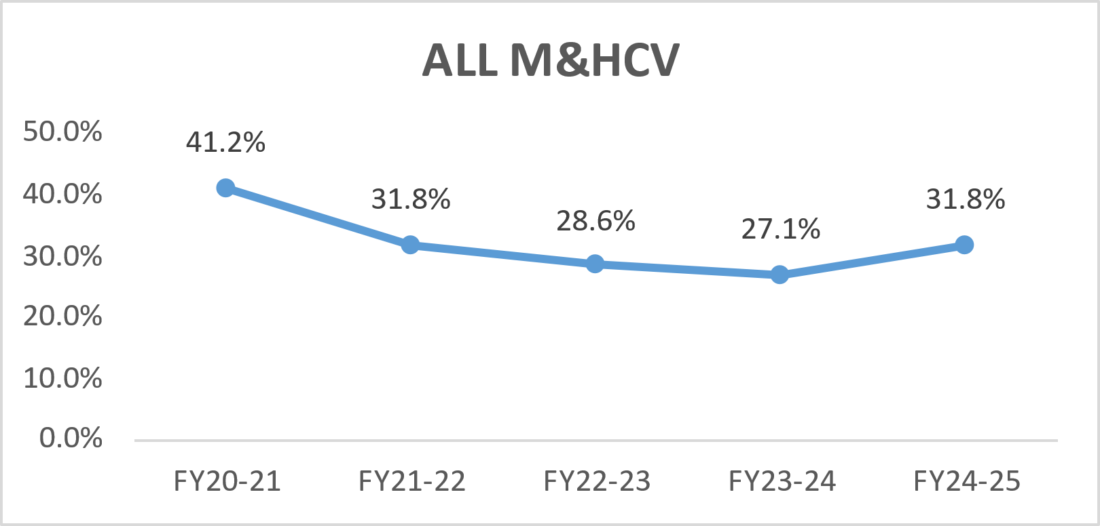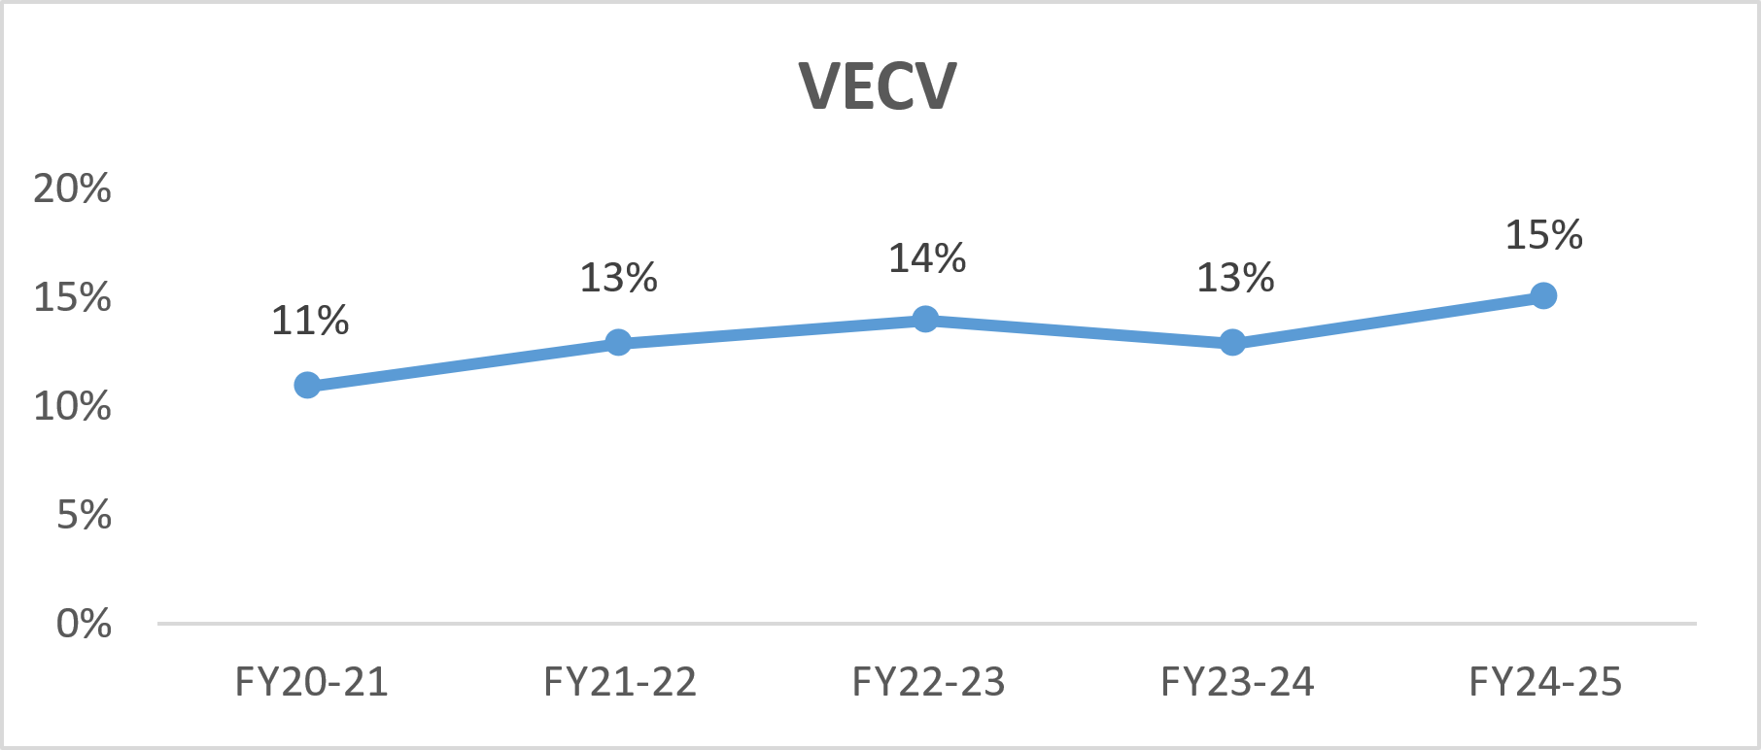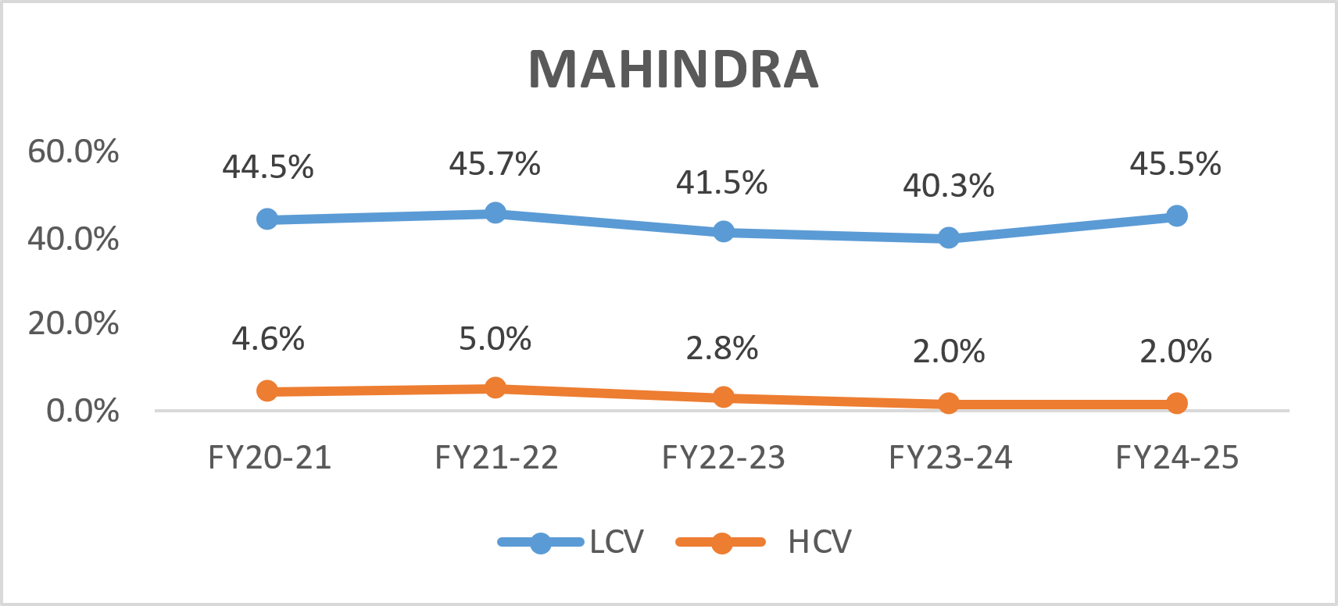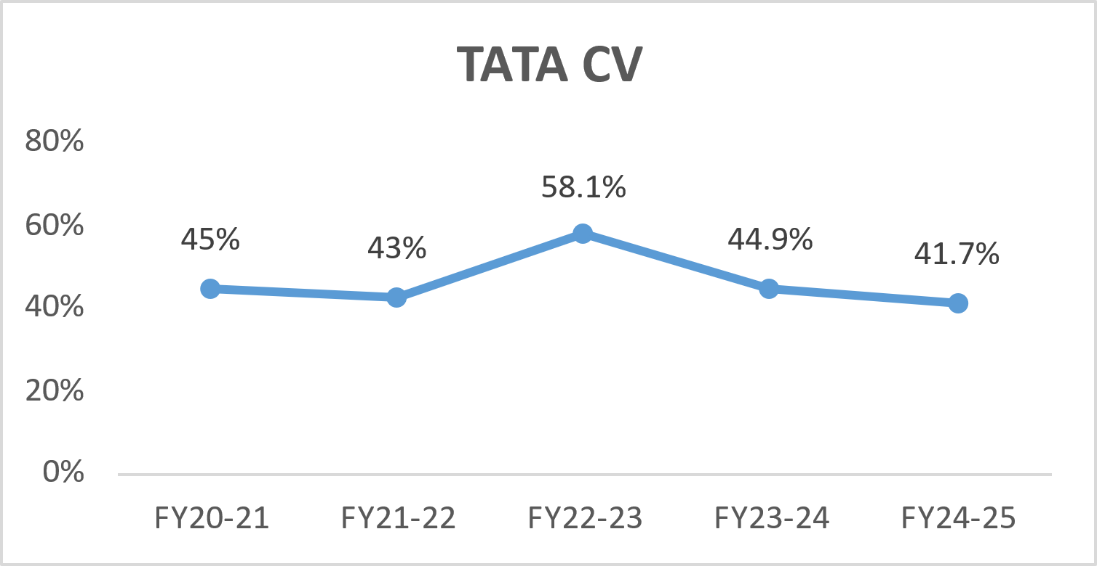

**TATA CV:** The chart represents the market share or performance of Tata Commercial Vehicles (CV) over five financial years.

Trend Analysis:

* FY20-21: Tata CV had a **45%** market share.
* FY21-22: The share declined slightly to **43%**.
* FY22-23: A significant increase to **58.1%**, which might indicate strong recovery or a market surge.
* FY23-24: A decline to **44.9%**, possibly due to external factors like supply chain issues, competition, or economic slowdown.
* FY24-25: Further decline to **41.7%**, showing a continued downward trend.

Key Insights:

* The highest market share was in FY22-23 (**58.1%**), suggesting a strong performance or recovery.
* The lowest point in the given period is FY24-25 (**41.7%**), indicating a consistent drop.

**Mahindra & Mahindra:** The chart represents the market share trends of Mahindra's Light Commercial Vehicles (LCV) and Heavy Commercial Vehicles (HCV) over five financial years (FY20-21 to FY24-25).

**Trend Analysis:**

* **LCV Market Share:**
  + Started at **44.5%** in FY20-21 and slightly increased to **45.7%** in FY21-22.
  + Declined significantly to **41.5%** in FY22-23 and further dropped to **40.3%** in FY23-24.
  + Recovered slightly to **45.5%** in FY24-25.
* **HCV Market Share:**
  + Began at **4.6%** in FY20-21 and rose to **5.0%** in FY21-22.
  + Saw a sharp decline to **2.8%** in FY22-23 and further to **2.0%** in FY23-24 and FY24-25.

**Key Insights:**

* **LCV Performance:** Mahindra’s LCV market share remained stable around the **40-45%** range, with a dip in FY22-23 but a recovery in FY24-25.
* **HCV Struggle:** The HCV segment has consistently declined from **5.0%** in FY21-22 to **2.0%** in FY23-24 and FY24-25, indicating challenges in competing in the heavy vehicle market.

**VECV:** The chart represents the market share trend of VE Commercial Vehicles (VECV) in the Medium & Heavy Commercial Vehicle (M&HCV) segment over five financial years (FY20-21 to FY24-25).

**Trend Analysis:**

* **FY20-21:** Market share started at **11%** , establishing a baseline for the period.
* **FY21-22:** Increased to **13%**, indicating growth and improved performance.
* **FY22-23:** Slight rise to **14%** , showing continued expansion and steady progress.
* **FY23-24:** Declined slightly back to **13%** , suggesting a temporary setback.
* **FY24-25:** Recovered to **15%** , marking the highest market share in the period.

**Key Insights:**

* **Overall Growth:** The market share grew from **11%** in FY20-21to **15%** in FY24-25, indicating a consistent upward trend over the five-year period.
* **Strong Recovery:** The growth to **15%** in FY24-25suggests that VECV successfully improved its market presence and competitiveness in the M&HCV segment, overcoming challenges faced in FY23-24.

**ALL M&HCV:** The chart represents the market share trend of Ashok Leyland (ALL) in the Medium & Heavy Commercial Vehicle (M&HCV) segment over five financial years (FY20-21 to FY24-25).

**Trend Analysis:**

* **FY20-21:** Market share was **41.2%** , the highest in the given period.
* **FY21-22:** Dropped significantly to **31.8%** , indicating a sharp decline.
* **FY22-23:** Continued declining to **28.6%** , showing a downward trend.
* **FY23-24:** Reached the lowest point at **27.1%** , suggesting continued market challenges.
* **FY24-25:** Recovered slightly back to **31.8%** , marking a turnaround.

**Key Insights:**

* **Consistent Decline:** From FY20-21 to FY23-24, Ashok Leyland's market share fell from **41.2%** to **27.1%** , a significant drop over the three-year period.
* **Recovery in FY24-25:** The market share increased to **31.8%** , indicating possible growth or stabilization in the M&HCV segment.

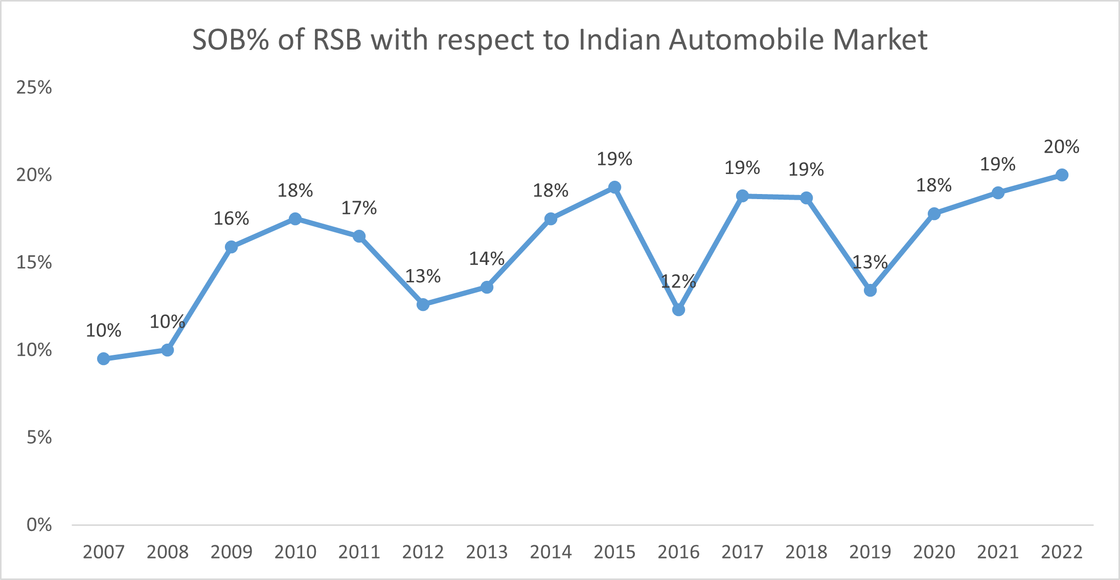**RSB’s Production Contribution to OEM’s (Value)**

|  |  |  |  |  |  |  |  |  |  |  |  |  |  |
| --- | --- | --- | --- | --- | --- | --- | --- | --- | --- | --- | --- | --- | --- |
| **RSB’s Product Contribution (2023)** | | | | | | | | | | | | | |
|  | | **TML** | | | **ALL** | | | **VECV** | | | **M&M** | | |
| **CV Category** | | **LCV** | **MCV** | **HCV** | **LCV** | **MCV** | **HVC** | **LCV** | **MCV** | **HCV** | **LCV** | **MCV** | **HCV** |
| **Avg Cost (INR)** | | **16,75,623** | **27,04,454** | **45,97,716** | **15,96,800** | **25,78,400** | **40,28,800** | **14,49,000** | **22,73,400** | **36,01,200** | **13,80,200** | **18,02,400** | **43,91,200** |
| **RSB** | **5TH Wheel Coupling** | **N/A** | **N/A** | **72,000** | **N/A** | **N/A** | **64,000** | **N/A** | **N/A** | **53,000** | **N/A** | **N/A** | **-** |
| **Live Axle** | **29,000** | **38,000** | **88,000** | **N/A** | **N/A** | **N/A** | **22,000** | **32,500** | **-** | **-** | **-** | **-** |
| **Dummy Axle** | **N/A** | **N/A** |  | **N/A** | **N/A** |  | **N/A** | **N/A** | **-** | **N/A** | **N/A** |  |
| **Propeller Shaft (Front + Rear)** | **18,000** | **35,000** | **43,000** | **20,500** | **33,000** | **42,500** |  |  |  |  |  |  |
| **Total** | **47,000** | **73,000** | **2,39,000** | **20,500** | **33,000** | **1,36,000** | **22,000** | **32,500** | **53,000** | **-** | **-** | **29,000** |
| **\*** | | **3%** | **3%** | **5%** | **1%** | **1%** | **3%** | **2%** | **1%** | **1%** | **0%** | **0%** | **1%** |

The graph indicates fluctuations in market share over the years, with periods of growth and decline. Between 2007 and 2019, RSB's market share varied between 10% and 19%, experiencing minor ups and downs. A significant spike is observed from 2020 onward, with the share rising from 18% in 2020 to 19% in 2021, followed by a slight rise to 20% in 2022. This suggests a major breakthrough or strategic shift in RSB’s business in recent years.

**Forecast for the Next 5 Years (2025-2030)**

**1. Market Size Projection**

* The Indian M&HCV market is expected to grow at a **CAGR of 5%** over the next decade
* Factors such as urbanization, industrialization, and increasing trade volumes will drive demand.

**2. Segment-wise Growth**

* **Trucks** : The truck segment will remain the largest contributor, accounting for ~70% of the market. Demand will be driven by freight movement, especially in sectors like FMCG, agriculture, and manufacturing.
* **Buses** : The bus segment will grow steadily due to urbanization and government initiatives like electric public transport systems.
* **Tippers** : Infrastructure projects will continue to drive demand for tippers.

**3. Electric and Alternative Fuel Vehicles**

* **Electric M&HCVs** : While still in nascent stages, the adoption of electric M&HCVs is expected to accelerate post-2025, supported by government incentives and declining battery costs.
* **CNG and Hydrogen** : CNG-powered vehicles will gain traction in urban areas, while hydrogen fuel cells may emerge as a viable option for long-haul transportation by 2030.

**4. Regional Trends**

* **North and West India** : These regions will dominate demand due to industrial hubs and logistics corridors.
* **South India** : Growth will be driven by IT hubs and port activities.
* **East India** : Infrastructure development projects will spur demand in states like Bihar, Jharkhand, and Odisha.

**5. Technological Advancements**

* **Telematics and IoT** : OEMs are increasingly integrating telematics solutions to enhance fleet management and improve operational efficiency.
* **Autonomous Vehicles** : While fully autonomous M&HCVs are unlikely in the near term, semi-autonomous features like adaptive cruise control and lane departure warning systems will become common.
* **Digital Platforms** : Online platforms for vehicle sales, financing, and after-sales services will gain prominence.

**6. Competitive Landscape**

* **Consolidation** : Smaller players may struggle to compete with larger OEMs offering advanced technologies and economies of scale.
* **Partnerships** : Collaborations between Indian OEMs and global players (e.g., Volvo Eicher, Daimler India) will continue to strengthen product portfolios.
* **Focus on Exports** : Indian OEMs are likely to increase exports to emerging markets in Africa, Southeast Asia, and Latin America.

**7. Regulatory Outlook**

* **Stricter Emission Norms** : Beyond BS-VI, India may adopt Euro VII standards by 2027-2028, further pushing OEMs to innovate.
* **Safety Regulations** : Mandates for advanced safety features like ABS, airbags, and electronic stability control will become standard.

**Assumptions and Methodology**

* 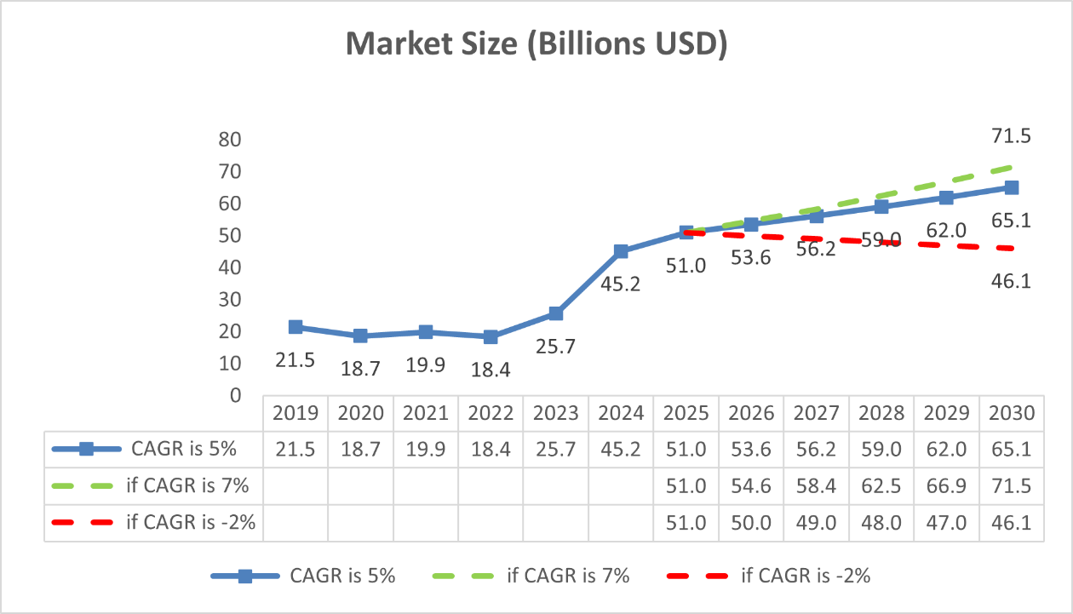The **CAGR of 5%** for the M&HCV segment was derived from historical growth rates (pre-pandemic and post-pandemic recovery) and projections from industry reports.

**Summary:** The graph shows three different market size scenarios projected from 2019 to 2030, measured in billions USD, with different Compound Annual Growth Rates (CAGR):

* Base scenario with 5% CAGR
* Optimistic scenario with 7% CAGR
* Pessimistic scenario with -2% CAGR

Key Insights:

1. Historical Stability (2019-2022):

* The market remained relatively stable around 20 billion USD
* Shows minimal fluctuation, suggesting a mature market during this period

1. Significant Growth Jump (2023-2024):

* All scenarios show a dramatic increase from about 25 billion to 45 billion USD
* This suggests a major market transformation or disruption expected during this period

1. Diverging Futures (2025-2030):

* Optimistic (7% CAGR): Reaches ~71 billion USD by 2030
* Base Case (5% CAGR): Achieves ~65 billion USD by 2030
* Pessimistic (-2% CAGR): Levels off at ~46 billion USD by 2030

**Sales Prediction of M&HCV Segment Of Top OEMs**

The sales forecast for Tata Motors' commercial vehicle segments (M&HCV) indicates steady growth with a projected 5% CAGR from FY2026 to FY2030. M&HCV sales are expected to rise from 1,01,694 units in FY2025 to approximately 1,29,790 units by FY2030. The green dashed line shows a more optimistic scenario with a 7% CAGR, reaching 142,631 units by 2030. In contrast, the red dashed line represents a negative growth scenario (-2% CAGR), with sales declining to 91,923 units by 2030. This analysis highlights the potential impact of market conditions on Tata M&HCV sales over the next decade.

The Mahindra M&HCV sales have been projected using a 5% CAGR based on past trends from FY20-21 to FY24-25. The blue line, based on a 5% CAGR, forecasts a steady increase from 7,000 units in 2025 to 8,933 units by 2030. The green dashed line represents a more optimistic 7% CAGR, reaching 9,818 units by 2030. Conversely, the red dashed line illustrates a negative growth scenario (-2% CAGR), with sales declining to 6,327 units by 2030. This analysis highlights possible market trends and the impact of varying growth rates on MTBL M&HCV sales.

The sales forecast for Ashok Leyland's M&HCV segment indicates steady growth based on a 5% CAGR. The blue line, following a 5% CAGR, predicts a steady rise from 120,275 units in 2025 to 153,504 units by 2030. The green dashed line, representing a 7% CAGR, suggests a more optimistic outlook, reaching 168,692 units by 2030. Meanwhile, the red dashed line, based on a -2% CAGR, indicates a decline to 108,719 units. These projections provide insights into potential market trends and the impact of varying growth conditions on ALL M&HCV sales.

The VECV M&HCV sales have shown steady growth from FY20-21 to FY24-25. The blue line, based on a 5% CAGR, forecasts a steady increase from 26,207 units in 2025 to 33,447 units in 2030. The green dashed line, representing a 7% CAGR, projects a more optimistic scenario with sales reaching 36,757 units by 2030. Conversely, the red dashed line, assuming a -2% CAGR, indicates a decline in sales to 23,689 units. These projections highlight potential sales trends under varying market conditions.

**Outcome (contribution to OEMs)**

* RSB’s contribution to Tata Motors: RSB holds a 3% market share in the Light Commercial Vehicle (LCV) segment of Tata Motors, making it a notable supplier in this category. Additionally, it contributes 2% in the Medium Commercial Vehicle (MCV) segment and a higher 6% in the Heavy Commercial Vehicle (HCV) segment, reflecting its strong presence in the larger vehicle category.
* RSB’s contribution to Ashok Leyland: In the case of Ashok Leyland, RSB plays a significant role by contributing 3% in LCVs, 2% in MCVs, and 4% in HCVs. This shows its well-distributed engagement across different commercial vehicle categories with the company.
* RSB’s contribution to VECV: RSB’s market share in VE Commercial Vehicles (VECV) is relatively smaller, with 2% in the LCV segment, 1% in the MCV segment, and 1% in the HCV segment. Despite its limited share, its presence in all three segments indicates its diverse product contribution to VECV.
* RSB’s relationship with Mahindra & Mahindra: RSB does not have any market share in the LCV or MCV segments for Mahindra & Mahindra. However, it holds a 1% share in the HCV segment, indicating a niche contribution to Mahindra’s heavy vehicle production.
* Overall growth in RSB’s market share: Over the years, RSB has witnessed a consistent increase in its Share of Business (SOB%) within the Indian Commercial Vehicle (CV) market. Its SOB% has risen significantly from 9.5% in 2007 to 21.1% in 2022, demonstrating its expanding role as a key supplier in the automotive industry.

**Suggestions**

1. Focus on HCV Segment

- This segment shows the highest contribution value (259,000) with a 5% share

- Represents the most lucrative segment

- Consider increasing investment and production capacity in this area

- Potential to expand market share beyond 5%

2. Strengthen TML Partnership

- Consistent 3% share contribution

- Shows stable engagement (73,000 and 33,000 contributions)

- Opportunity to deepen relationship and increase share percentage

- Could explore additional product lines with TML

3. Areas Needing Attention

- M&M segment shows minimal contribution (0% share)

- LCV segment shows declining trend (from 47,000 to no value)

- Consider:

* Product development specific to these segments

* Competitive analysis to understand market gaps

* Strategic partnerships to increase presence

4. Growth Opportunities

- VECV segment has only one contribution (32,500) at 1% share

- Room for growth through:

* New product development

* Enhanced service offerings

* Increased collaboration with VECV

5. Resource Allocation Recommendations

- Prioritize HCV segment investment

- Develop strategy to revive LCV segment

- Create dedicated team for M&M account development

- Investigate success factors in high-performing segments for replication

**Bibliography**

Websites

* <https://www.tatamotors.com/wp-content/uploads/2023/10/abridged-annual-report-2018-2019.pdf>
* <https://static-assets.tatamotors.com/Production/www-tatamotors-com-NEW/wp-content/uploads/2023/12/annual-report-2019-2020-1.pdf>
* <https://www.bseindia.com/bseplus/annualreport/500477/5004770319.pdf>
* <https://www.ashokleyland.com/backend/wp-content/uploads/2024/03/Annual-Report-FY-2021-22.pdf>
* <https://www.mahindra.com/resources/investor-reports/FY20/Annual-Reports/MM-Annual-Report-2019-20.pdf>
* <https://www.mahindra.com/sites/default/files/2024-01/MM-Annual-Report-2022-23.pdf>
* <https://eicher.in/content/dam/eicher-motors/investor/financial-and-reports/annual-reports/Eicher%20Motors%20Integrated%20Annual%20Report%202020-21.pdf>
* <https://eicher.in/content/dam/eicher-motors/investor/financial-and-reports/annual-reports/Eicher%20Motors%20Annual%20Report%202018-19.pdf>